**“Boardly” application (Bug reports)  
  
  
1. Instead of “Login” there appears “Sign In” page, which wants a mail to send a magic link (like register confirmation). Near “Login” button must be also “Sign In”.**

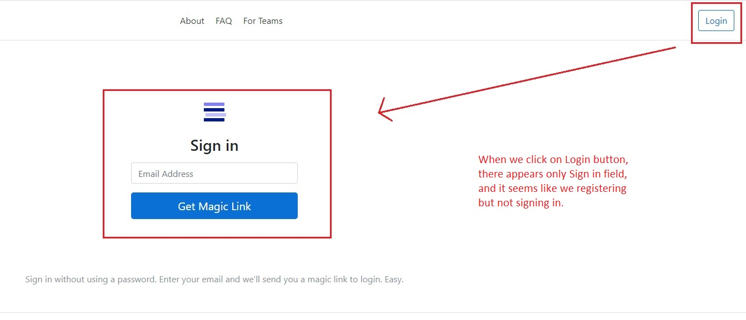

**2. At the very bottom is located “Feedback” button, which does not working.**

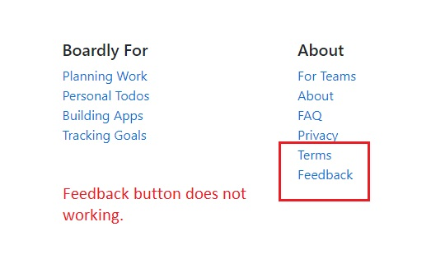

**3. In “To do” list written “Mom and Pop” words. If there is mom which means Mother, Pop is music genre but not Pap` Father.** 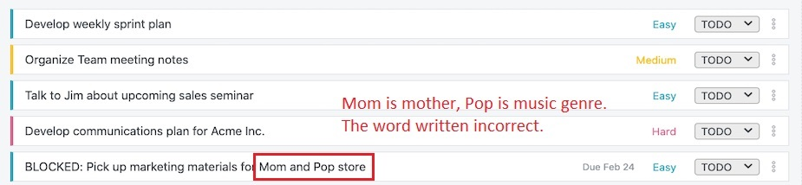

**4. The app doesn’t send any message to mail.**

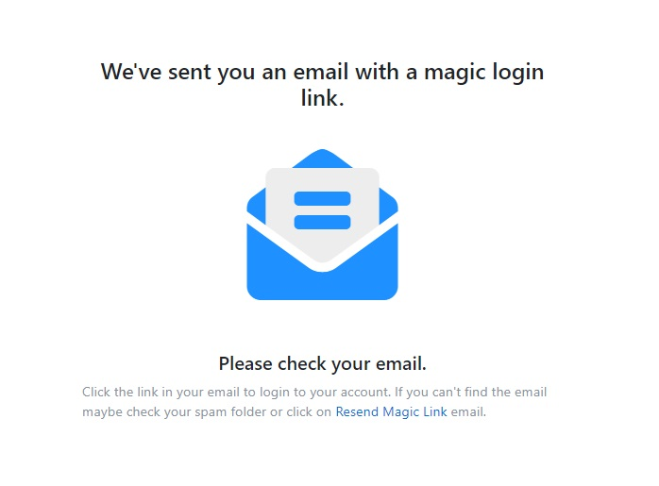

**5. Users should not see this wrong tutorial, in the video we must see “The magic link has been successfully sent to your mail”.**

